Help with online reading
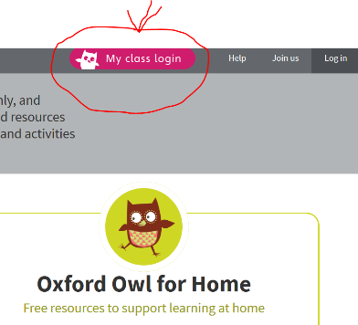
How to select the right book for your child on Oxford Owl
- Access the website www.oxfordowl.co.uk – link available on the class page of our website or the Home Learning Menu
- In the top right corner click the My class login
- On the drop down menu enter your class login or use Robins (see image).
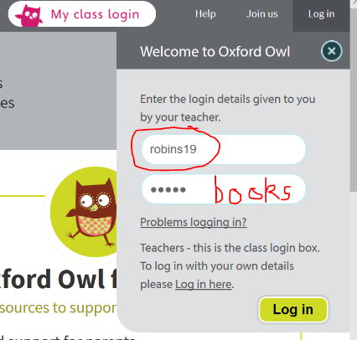
- Click the My Bookshelf
Book are organised by Age, Series and Themes
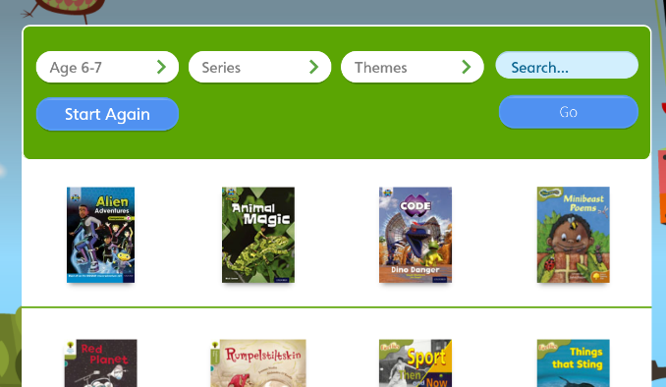
- Use the table below to find the correct shelf for you to select a book from. As a guide, check the colour book band you have in school or if you are a non-book band reader select by age. These are written in order with the first colour being the easier getting progressively harder.
Lilac, Pink, Red, Yellow | Age 4-5
Yellow, Blue (light), Green, Orange | Age 5-6
Turquoise, Purple, Gold, White | Age 6-7
Lime, Brown, Grey | Age 7-8
Grey, Dark Blue | Age 8-9
Dark Blue, Dark Red | Age 9-10

For children reading at Yellow level and above....
Listen to your child read the first few pages, if they are having to sound out most words and not remembering new words they encounter, don’t let them struggle as reading will quickly be seen as a chore Just read the book to them or encourage them to click on the AUDIO button. Then try another book on the shelf or a book on an easier colour band.
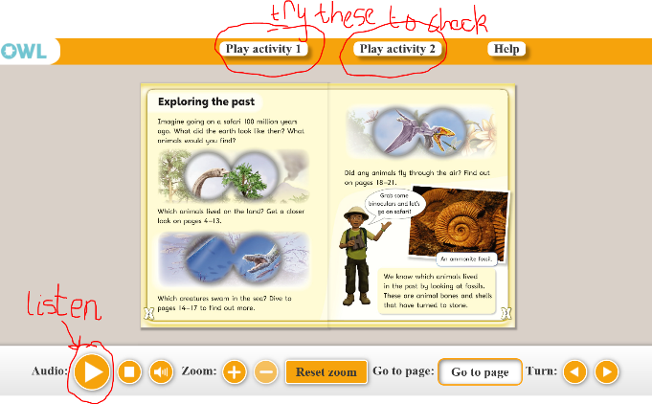
If they can read their chosen book confidently - without having to sound out (decode) or ask an adult - and have practised reading with fluency and expression (not robot reading!), listen to the audio try the Play activities, then try an alternative book on the shelf or the next level.

